Step 1. After that Don’t change anything keep everything default and click on Launch Instance.

ONCE YOUR instance is up and running and you see this page click on CONNECT in the top right corner.

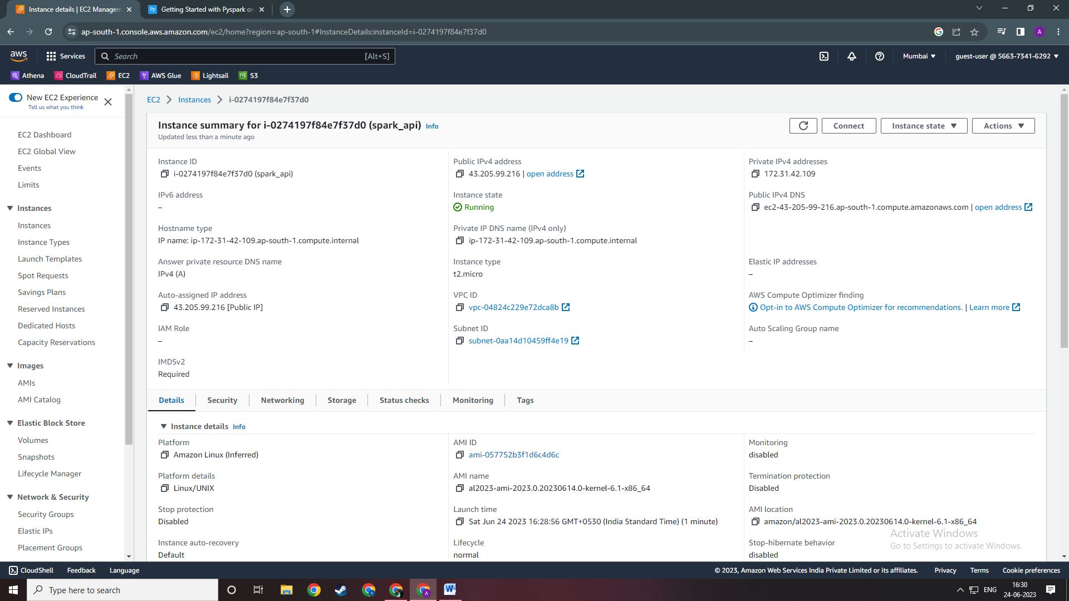

Step 2. After clicking on Connect see that you click on SHH cliet as shown below.  
  
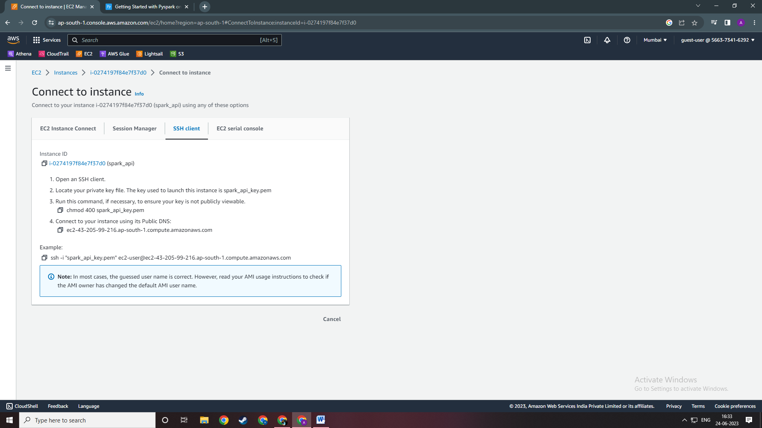

COPY the command under Example.   
ssh -i "spark_api_key.pem" [ec2-user@ec2-43-205-99-216.ap-south-1.compute.amazonaws.com](mailto:ec2-user@ec2-43-205-99-216.ap-south-1.compute.amazonaws.com)

Step 3. Open your command prompt and do in the directory in which you have store your pemp file using the “cd” command. Once you are into you same directory as your pem file paste the command you just copied.

After pressing enter, a question will prompt to add the host to your known_hosts file. Type **YES** .

This will help to recognize the host each time you’re trying to connect to your instance. And that’s it! Now you’re logged in on your AWS instance.   
  
If you get error saying not authorized user OR Permission denied and you can’t connect. Do the following steps.

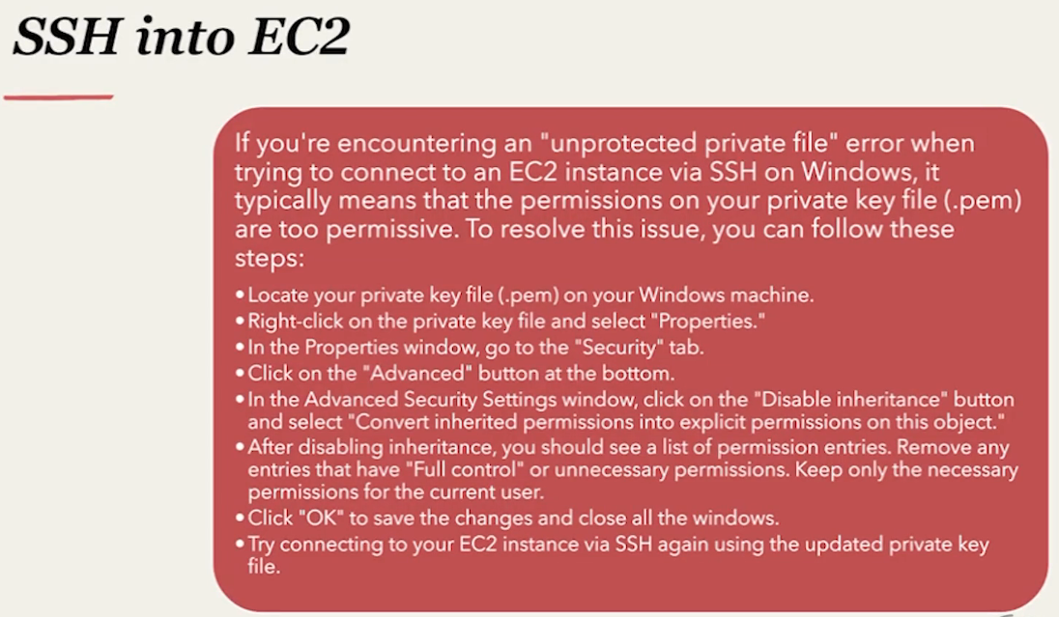

Only keep the user you currently are in the permission list.

After doing this your permission in settings should look like this .

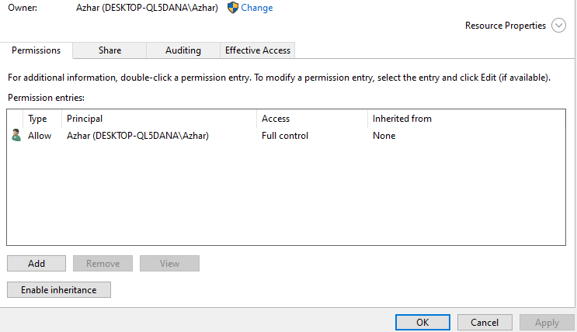

Step 4. After completing the following steps you should be able to connect with your EC2 machine

